Optimization in Relation to Problem-Solving

### Case Study: Climate DatAset Exercise 1-3

**Basel Mean Temperature 1962:**500 Iterations | Alpha 0.1 | Theta 0 = 0.3 | Theta 1 = 7.5

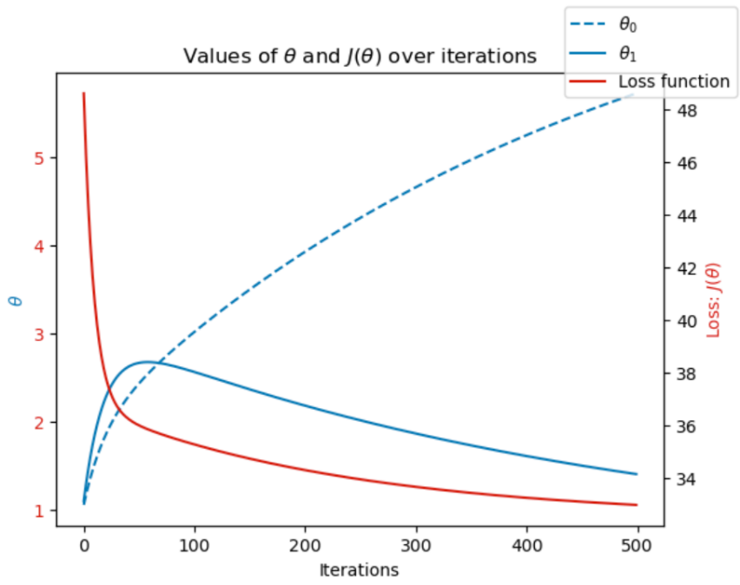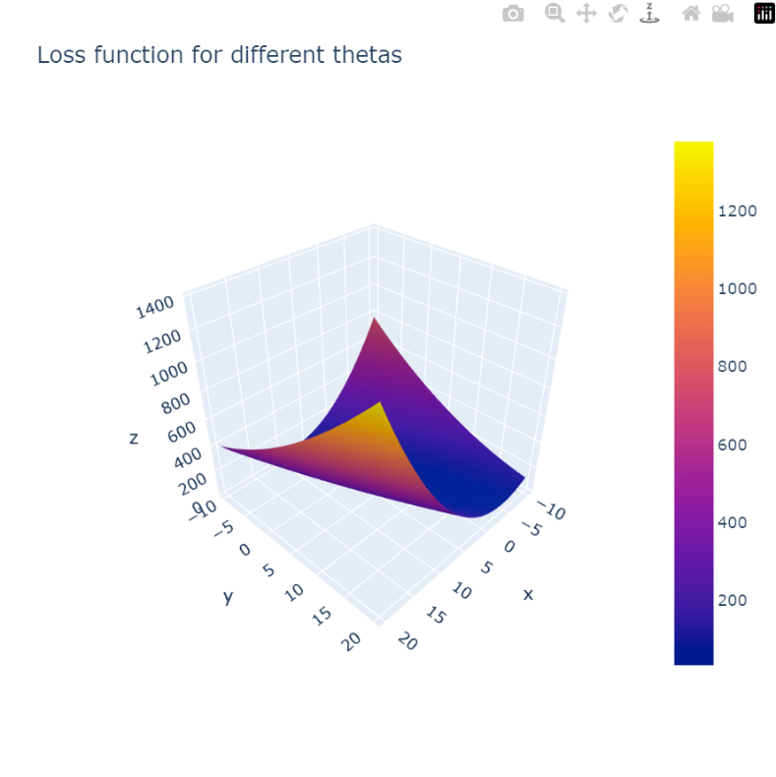

**Basel Mean Temperature 1990:**500 Iterations | Alpha 0.01 | Theta 0 = 0.6 | Theta 1 = 10

**Basel Mean Temperature 2019:**500 Iterations | Alpha 0.01 | Theta 0 = 1.5 | Theta 1 = 9

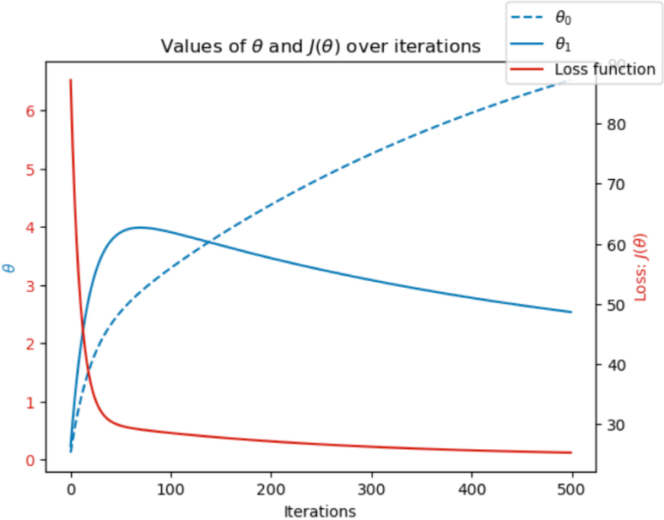

**Heathrow Mean Temperature 1962:**1000 Iterations | Alpha 0.07 | Theta 0 = 1.6 | Theta 1 = 9

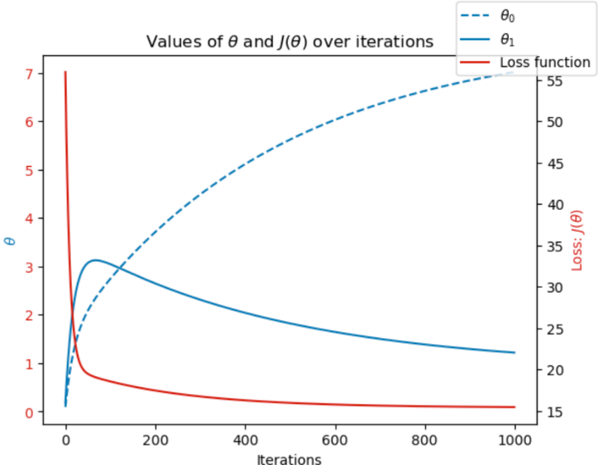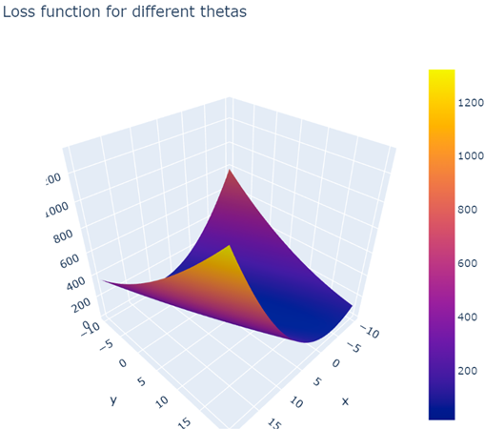

**Heathrow Mean Temperature 1990:**1000 Iterations | Alpha 0.03 | Theta 0 = 0.3 | Theta 1 = 11.2

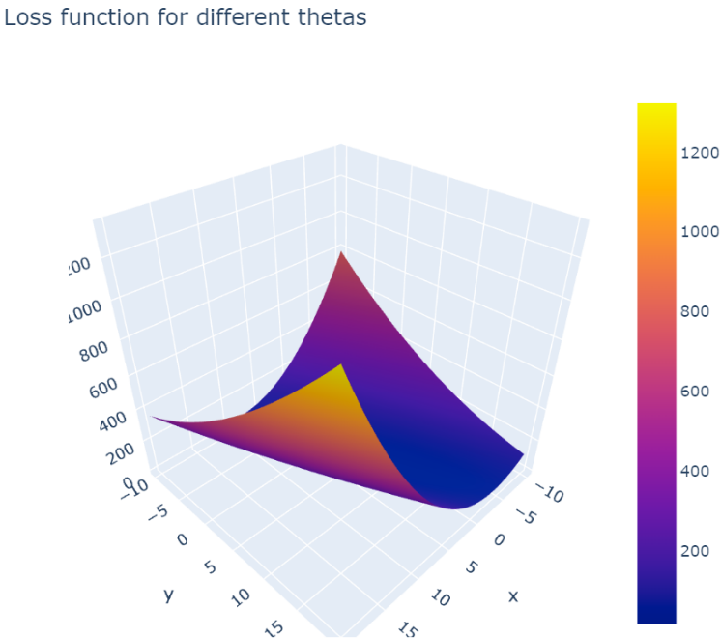

**Heathrow Mean Temperature 2019:**1000 Iterations | Alpha 0.07 | Theta 0 = 1.6 | Theta 1 = 9

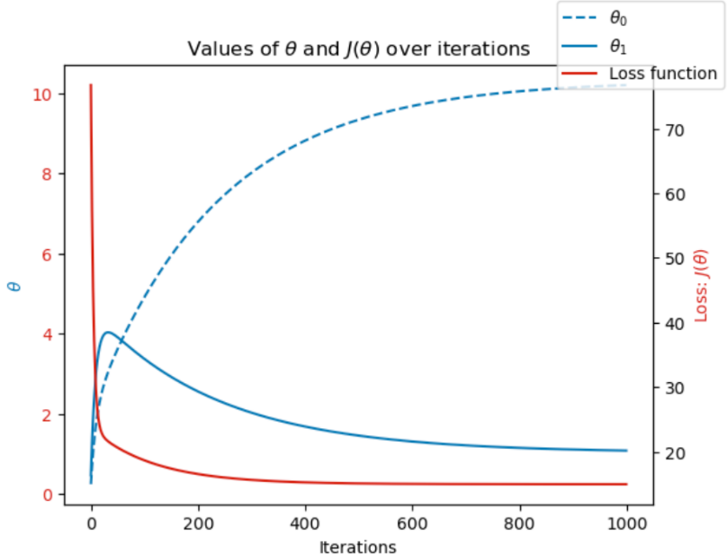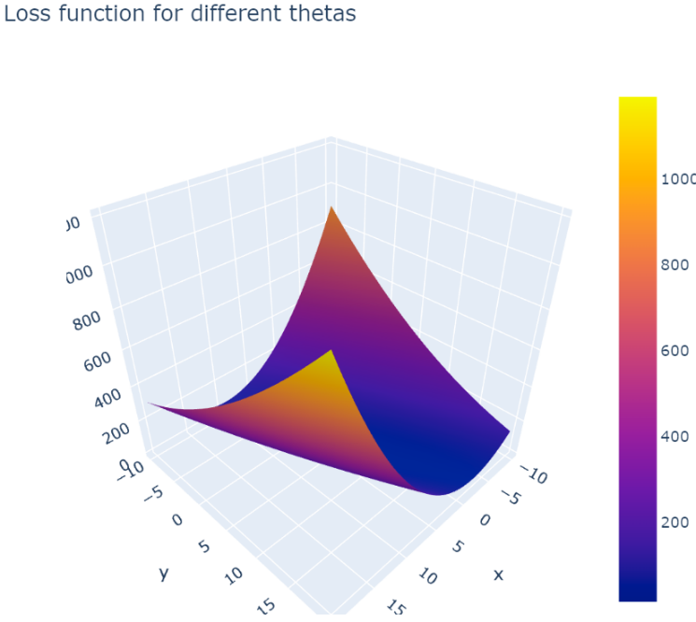

**Heathrow Mean Temperature 1962:**1000 Iterations | Alpha 0.07 | Theta 0 = 1.6 | Theta 1 = 9

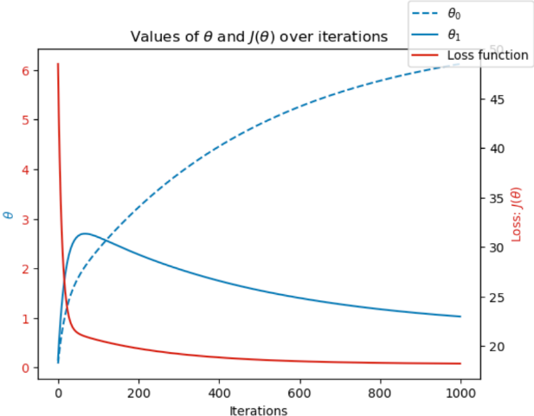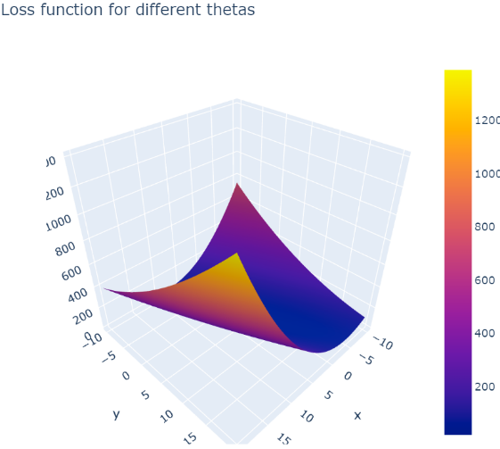

**Heathrow Mean Temperature 1990:**1000 Iterations | Alpha 0.03 | Theta 0 = 0.3 | Theta 1 = 11.2

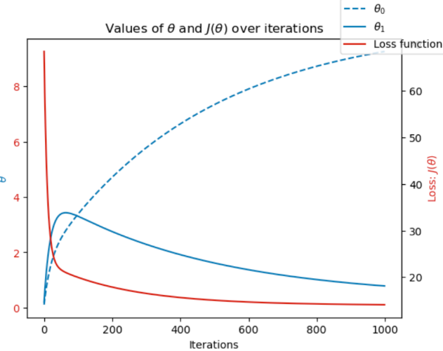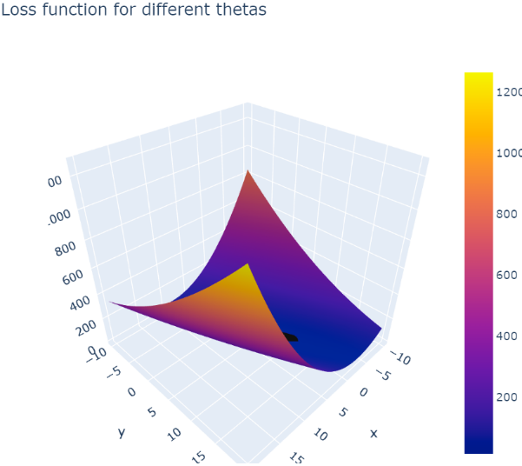

**Heathrow Mean Temperature 2019:**1000 Iterations | Alpha 0.07 | Theta 0 = 1.6 | Theta 1 = 9

